

Rad Source Biological

Irradiation and Sterilization System
Proposal

Rad Source Technologies, Inc.

20283 State Road 7, suite 107
Boca Raton, FL 33498
Phone: 561.482.9330
Fax: 561.482.9352

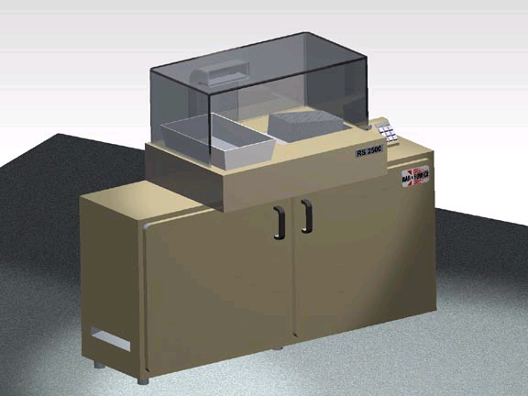
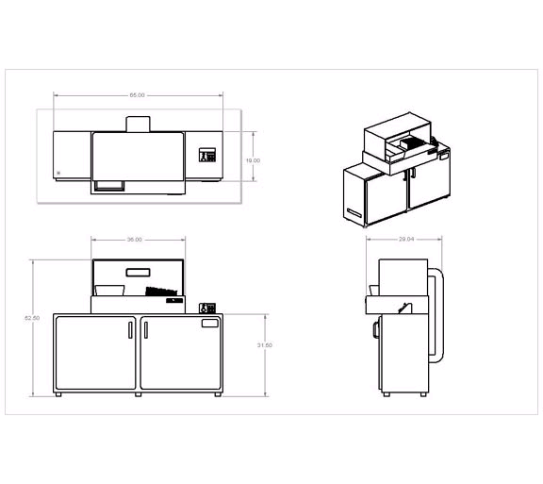

I. General System Description

Proposed Technology Overview

Rad Source Technologies, Inc. proposes to manufacture a biological irradiation and sterilization system designed to accept letter and express mail parcels not to exceed 3.5 mm in thickness. Our proposal encompasses a self contained turn key system manufactured in accordance with all Local, State and Federal requirements.

Rad Source Technologies, Inc. proposed system is a unique product that allows parcels to be manually fed through a slot into the irradiation chamber. A high power electron accelerator provides the sterilization source reducing specific biological threats by 8 log reductions. Parcels pass through the sterilization chamber and drop through the opposite portal in 20-30 seconds depending on parcel size. Radiation shielding design allows installation and operation without environmental concerns. It includes identification of envelopes that cannot be guaranteed to receive uniform dose such as outside of normal thickness or containing metal objects. The machine is also equipped with a negative pressure hood and filtration to reduce air born contamination.

As an irradiation system integrator with considerable experience, Rad Source Technologies, Inc. can document the following advantages of this approach versus alternative sterilization and irradiation techniques:

- Speed … Rad Source Technologies, Inc. system design provides excellent cost versus throughput ratios compared with bulky gamma Ray irradiators and lower energy sources.
- Floor space … Small configuration allows placement with minimal space impact.
- Range of Dosage … Dose rates can be adjusted resulting in increased throughput.
- Range of Temperature … Equipment may be operated through a broad temperature and humidity range without degradation.
- Repairability … Simple compact design provides reliability and ease of maintenance.
- Installed Base … Rad Source Technologies, Inc. has installed more than 20 biological and plasma based irradiation units throughout North America.
- Acceptance … Equipment validation will include inert threat sample sterilization consistent with government defined procedures.

Proposed System Overview
The proposed system is a complete turn key irradiation and sterilization system consisting of the following major components:

- High energy electron generator/accelerator
- Shielded irradiation and sterilization chamber
- Pass through parcel material handling system
- Ergonomic operator interface panel
- Environmental hood
- Documentation and accreditation

Installation, Training, and After-Sale Support

Installation will be performed by Florida based Rad Source Technologies, Inc. staff over the course of 1-2 days, depending on final system design and utility availability. The is responsible for moving the equipment from the dock to the installation site and providing shipping and refuse disposal. Training would commence immediately after installation

Documentation

Rad Source Technologies, Inc. will provide a full set of documentation to as part of the delivered system. All documentation will be provided in English.

Overview of Rad Source Technologies, Inc.

Rad Source Technologies, Inc. was founded in 1996 to provide state of the art irradiation and sterilization products for the expanding needs of American Industries, as well as maintaining a strong foundation in traditional technologies. Beginning with the patented and FDA approved X-Ray blood irradiation procedure Rad Source Technologies, Inc. has expanded products and services to cover a broad spectrum of biological irradiation and sterilization procedures and equipment.

Rad Source Technologies, Inc. has established marketing relationships with power supply and specialty device manufacturers such as Kaiser and Livingston products, which in conjunction with Rad Source Technologies, Inc., cater to a worldwide market. Our philosophy has been established through extensive personal experience and by reducing costs through global marketing and parallel manufacturing. As the North American based manufacturing, marketing and development entity, Rad Source Technologies, Inc. is uniquely suited to assist with biological threat reduction applications, supplying a full range of products to support various agencies and industries.

Jointly, Rad Source Technologies, Inc. and our partners represent what we feel are the highest quality systems available today. Together with our supplier and distribution partners, Rad Source Technologies, Inc. will continue to provide cost effective solutions to the North American marketplace.

II. Technical Specifications

Item No. 1 Electron generator/accelerator

Electrons will be generated and accelerated using a pulsed high velocity electron generating system. Operating at one pulse per second each pulse discharges high velocity electrons resulting in an average dose of 1.5 kGy. Specific threats including spores will require three pulses or 5 kGy resulting in an 10 log threat reduction as defined in the literature.

Item No. 2 Shielded enclosure

A Radiation shielded enclosure will be provided and houses the irradiation and sterilization chamber. Chamber dimensions will be adequate to process business and express mail envelopes with the following guidelines:

* Business or personal letter to five sheets of paper folded three times enveloped (4.5” X 9.5”)

* Express mail to 15 sheets plus envelope (9.5” X 12.5”)

* Enclosure will be manufactured in accordance with Good Manufacturing Practices (GMP) with the approximate size of 66” X 36” X 56” high.

* Equipment will operate from a single power utility drop of 220 Volts single phase, 50 amp service.

Item No. 3 Material handling

An envelope material handling mechanism will be provided. Designed to automatically grab and process parcels and envelopes consistent with specified requirements parcel processing system provides motion and timing sufficient to assure irradiation and sterilization within the chamber. Processed product will flow through the chamber and drop into a customer provided bin or basket.

Item No. 4 Radiation Safety

The Equipment will meet 21 CFR 1020.40 requirements for a cabinet X-ray system.

Item No. 5 Ergonomic operator interface

An operator interface panel will be attached to the shielded enclosure adjacent to the parcel/envelope entry point. Operator interface will monitor energy selection (defined for specific threats) and general machine operation. Status lights at the interface panel provide machine status indicators.

Item No. 6 Documentation and accreditation

A comprehensive documentation package will accompany the system including machine schematics and accreditation materials. Documentation will include recommended validation tests sufficient to assure machine operation consistent with required or desired threat reduction. Procedures may be internally developed or Rad Source Technologies, Inc. can optionally provide validation and maintenance services at regularly scheduled intervals at nominal service rates. Validation tests may require material or services outside Rad Source Technologies, Inc. standard business practices. Rad Source Technologies, Inc. will assist The in identifying practical and prudent tests and companies or products capable of providing product or services. Upon request, a written quotation covering these services and/or products will be made available prior to machine installation.

III. Capital Purchase Pricing

Rad Source Technologies, Inc. is pleased to quote the biological irradiation and sterilization system described in this proposal contingent on items defined in paragraph four for approximately$89,000.00 US Dollars (Eighty Nine Thousand Dollars).

Terms

Sales and use tax are the responsibility of the buyer.

Delivery … Delivery will be made to facility 120-150 days ARO.

Pricing valid for 20 days.

All Purchase Orders must be made out directly to Rad Source Technologies, Inc.

FOB Buford, GA
30% with Order (escrow)
60% Upon completion of factory validation tests
10% upon completion of installation at customers facility

IIII Contingencies

Rad Source proposes to manufacture a biological and sterilization system designed to reduce biological threats contained in parcels to a level of 10 log reduction ( ten to the minus ten reduction). Testing is required to develop biological threat reduction and elimination techniques and agents sufficiently similar to defined threats must be procured and analyzed. Rad Source Technologies, Inc. reserves the right to withdraw this proposal without penalty contingent on, A) performance and delivery of the high velocity electron generator and, B) Ability of said electron generator to reliably inactivate biological threats. Proposal also requires strict confidentiality. The agrees to announcement of the order.

Warranty

Note: Constant product improvements from our suppliers necessitates that Rad Source Technologies, Inc. reserve the right to change any of the above specifications without notice.

IV. Rad Source Technologies, Inc. Warranty Statement

Rad Source Technologies, Inc. warrants that new products or equipment of it's own manufacture will be free from defects in material or workmanship for a period of one (1) year from the original shipping date plus one (1) month to allow for shipping for a total of 13 months. Rad Source Technologies, Inc. at its option will either repair or replace defective equipment.

During the first six (6) months shop labor, field labor and travel time will be without charge provided repairs meet warranty terms and the work is performed during normal working hours. There will be a charge for shop labor, field labor, and travel time after the first six (6) months of warranty. Following initial shipment of equipment service department travel expenses and per diem are at the owners expense. All shipping expenses including packaging or crating charges and transportation of parts and equipment both ways are at the owner's expense.

Rad Source Technologies, Inc.'s sole obligation is to repair or replace equipment found to be defective. This warranty does not extend to glassware, high voltage cables or consumables nor to damage resulting from accident , misuse, overheating, neglect or improper application, use of attachments not provided with the equipment or damage caused by improper power or ambient conditions.

This warranty is void when installation, service, or repairs are performed by service personnel not authorized by Rad Source Technologies, Inc., or when any part of the equipment is altered by others. This warranty extends only to the first end user and is not transferable. Reconditioned or used equipment is sold " as is" with no warranty unless otherwise indicated.

Rad Source Technologies, Inc. acts as an agent or dealer for a number of components and equipment not of its own manufacture. When such equipment is purchased from or through Rad Source Technologies, Inc., Rad Source Technologies, Inc. will pass through to the first end user manufacturer's warranty and the terms of the manufacture's warranty.

Warranty considerations for field labor and travel by Rad Source Technologies, Inc. personnel are the same for items manufactured by Rad Source Technologies, Inc. and items sold or represented by Rad Source Technologies, Inc.. Transportation of items is the same in both cases , i.e. transportation both ways is the responsibility of the owner. Please refer to paragraph two (2) above for details. To facilitate warranty repairs and insure that Rad Source Technologies, Inc.’s work on , and possible removal of , all or part of the equipment is authorized, Rad Source Technologies, Inc. must have a company purchase order covering the work. Wording that includes " subject to warranty considerations " may be used so long as the purchase order authorizes possible labor, travel and transportation cost. A Return Authorization must be obtained prior to the return of any component to Rad Source Technologies, Inc..

